Once you log in to the application, you will be brought to the homepage, which is your Student Information Dashboard. Here you will see a list of all the students you have worked with recently. You can view, or make changes to any student by clicking on the buttons.

You can search for a student who might not be displayed by entering the Last name, and pressing ENTER

You can also search for all students in a particular grade, or search by Male or Female.

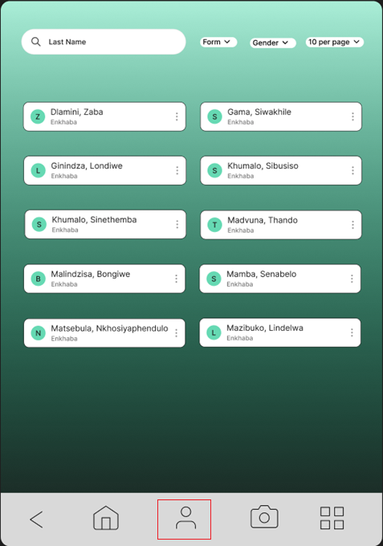

To add a new student, you can click the **Student Interview** button at the bottom, outlined in the picture above.

On the **Student Interview** page, you will see a navigation bar at the top of the page to move through the tabs quickly.

On the first tab, there is a place to **add a photo** directly to the student's profile during the interview process.

You can click “Save Student” at any time to save your changes to the database.

**School Tab**: The Schools Info tab contains fields for the current (primary) school, and the high school where they hope to be sponsored.

For the Primary School and High School, you will select an entry from school names already entered into the system.

**Homestead Tab**: Each student is attached to a ‘Homestead’. We can have multiple students at a homestead. You will only need to record the details for the homestead once. You can search for an existing homestead using the search bar or add a new one by clicking “Create New Homestead.”

We will need to add to this screen a Checkbox for “**Homestead Visit Needed**”

We might also record the date a **Home Visit** is done.

**Family Tab**:

Details for the Mother & Father are at the top of the page.

You can add a new sibling by clicking “Add Sibling” or edit the derails for one of the siblings by clicking “Edit Sibling”.

**Comments Tab**:

This is perhaps to most important section – where you will record your thoughts on the student

In the Comments box, you can just write notes.

The Recommended check box is whether or not you feel this student should be considered.

The Priority slider is used to rank how needy this student is – the range is from 1 (well supported) to 10 (in great need)

Once finished, you will click “Save Student” to finalize the data collection.

Once all information is filled out, you will click “Save Student” to add the student to the database.